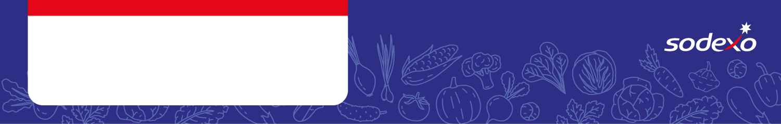
Food Safety Management System
Forms
Week 3

Menu Item   Tick the allergens that are in the dish  Insert ‘MC’ where the label states ‘May Contain’ | Celery | Cereal  containing  gluten * | Crustaceans | Eggs | Fish | Lupin | Milk | Molluscs | Mustard | Nuts** | Peanuts | Sesame seeds | Soya | Sulphur  Dioxide &  Sulphites
Veggie Meatballs, Jacket Potato

Pork Sausage, Jacket Potato, Gravy |  | Wheat
Quorn Sausage, Jacket Potato, Gravy |  | Wheat
Roast Chicken Dinner, Gravy

Roast Quorn, Jacket Potato, Gravy |  | Wheat
BBQ Chicken, Jacket Potato |  | Wheat/ Barley
Tomato Ratatouille, Jacket Potato
White Fish, Jacket Potato
Veggie Sausage, Jacket Potato |  | Wheat

