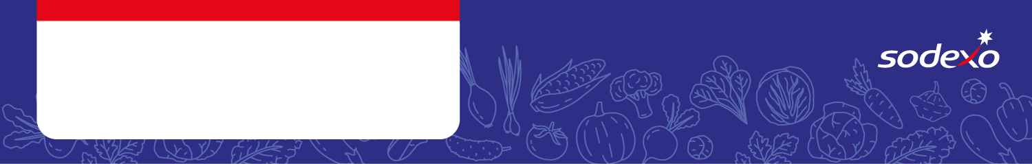
Food Safety Management System
Forms
Week 2

Menu Item   Tick the allergens that are in the dish  Insert ‘MC’ where the label states ‘May Contain’ | Celery | Cereal  containing  gluten * | Crustaceans | Eggs | Fish | Lupin | Milk | Molluscs | Mustard | Nuts** | Peanuts | Sesame seeds | Soya | Sulphur  Dioxide &  Sulphites
Pork Sausage, Jacket Potato |  | Wheat
Quorn Sausage, Jacket Potato |  | Wheat
Chicken Curry, Jacket Potato

Sweet Potato & Chickpeas Curry, Rice, Peas

Roast Chicken Dinner, Gravy

Roast Quorn & Jacket Potato |  | Wheat
Beef Bolognese, Jacket Potato

Veggie Bolognese, Jacket Potato

White Fish , Jacket Potato
Veggie Sausage, Jacket Potato |  | Wheat

