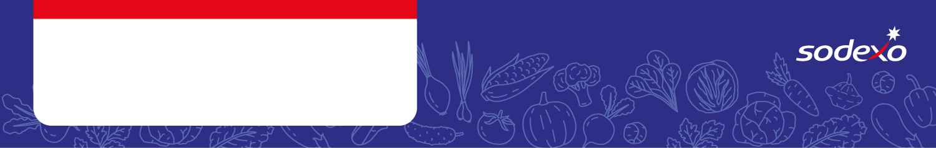
Food Safety Management System
Forms
DESSERTS

Menu Item   Tick the allergens that are in the dish  Insert ‘MC’ where the label states ‘May Contain’ | Celery | Cereal  containing  gluten * | Crustaceans | Eggs | Fish | Lupin | Milk | Molluscs | Mustard | Nuts** | Peanuts | Sesame seeds | Soya | Sulphur  Dioxide &  Sulphites
Autumn Fruit Sponge |  | Wheat / Oats
Pear Upside Down Pudding |  | Wheat
Fruit Shortbread/ / Chocolate Swirl Shortbread |  | Wheat
Yoghurt, / Choco Caramel Mousse / Custard /
Ice Cream

Apple & Cinnamon Pinwheel |  | Wheat
Lemon & Oat Cookie/ Lemon Drizzle Flapjack  Apple Flapjack |  | Oats
Carrot Cake |  | Wheat
Pear & Ginger Cake / Coconut & Lime Cake |  | Wheat
Vanilla Sponge / Iced School Cake |  | Wheat

