Curriculum Statement for EYFS 2025/26
Intent
What we aim to achieve:
Early Years education at Red Oaks means an exciting and balanced curriculum that encourages exploration and independent learning. We always put the child at the centre of the learning, making learning enjoyable and accessible to all. Teachers respond to the children and plan accordingly. Therefore, the planning is fluid and dynamic and responds to the child meaning every child is an individual and our child initiated, response-based planning aims to provide them with opportunities to develop their abilities.

“All children deserve the care and support they need to have the best start in life. Children learn and develop at a faster rate from birth to five years old than at any other time in their lives, so their experiences in early years have a major impact on their
future life chances. A secure, safe, and happy childhood is important in its own right. Good parenting and high-quality early learning provide the foundation children need to fulfil their potential.
The EYFS sets the standards that all early years providers must meet to ensure that children learn and develop well and are kept healthy and safe. It promotes teaching and learning to ensure children’s ‘school readiness’ and gives children the right foundation
for good future progress through school and life. The EYFS is about what children learn, as well as how they learn. Effective practice is a mix of different approaches. Children learn through play, by adults modelling, by observing each other and through adult-guided learning.” (EYFS framework Sept 2025)

The EYFS seeks to provide:
• Quality and consistency in all early years settings, so that every child makes good progress, and no child gets left behind.
• A secure foundation through planning for the learning and development of each individual child and assessing and reviewing what they have learned regularly.
• Partnership working between practitioners and with parents and/or carers.
• Equality of opportunity and anti-discriminatory practice, ensuring that every child is included and supported.
There are four overarching principles which shape our practice in the early years. These are:
• Every child is a unique child, who is constantly learning and can be resilient, capable, confident, and self-assured.
• Children learn to be strong and independent through positive relationships.
• Children learn and develop well in enabling environments with teaching and support from adults, who respond to their individual interests and needs and help them to build their learning over time. Children benefit from a strong partnership between practitioners and parents and/or carers.
• Importance of learning and development. Children develop and learn at different rates.

Implementation
How we will achieve this:
Throughout the EYFS, children will be working towards the 17 Early Learning Goals which are included in the 7 main areas which are;
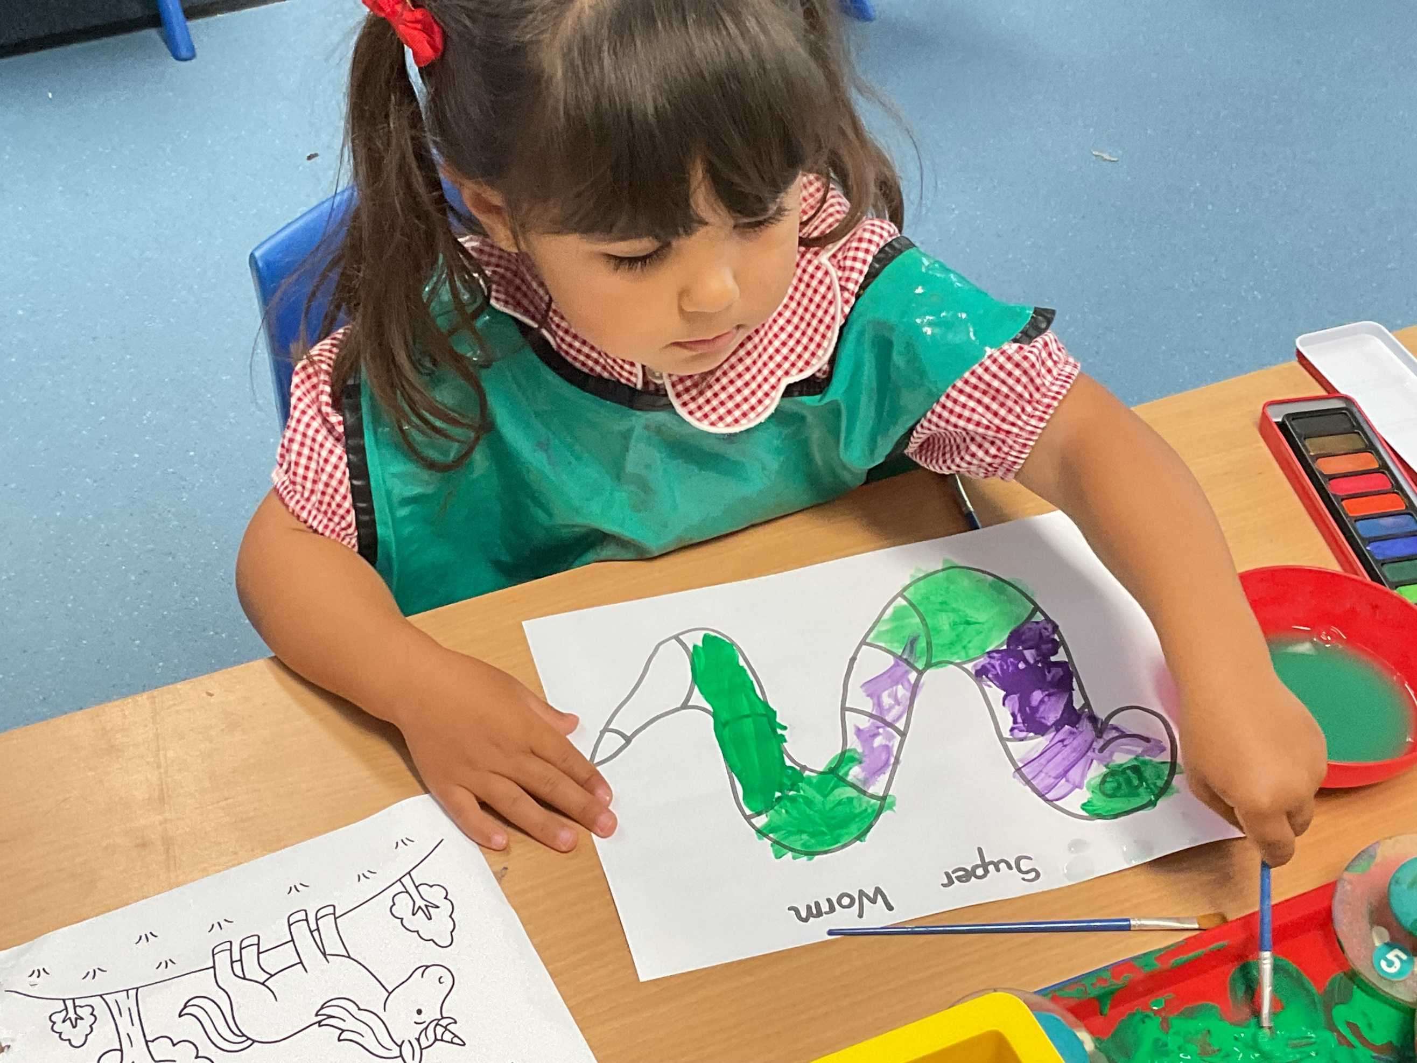
- Communication and Language
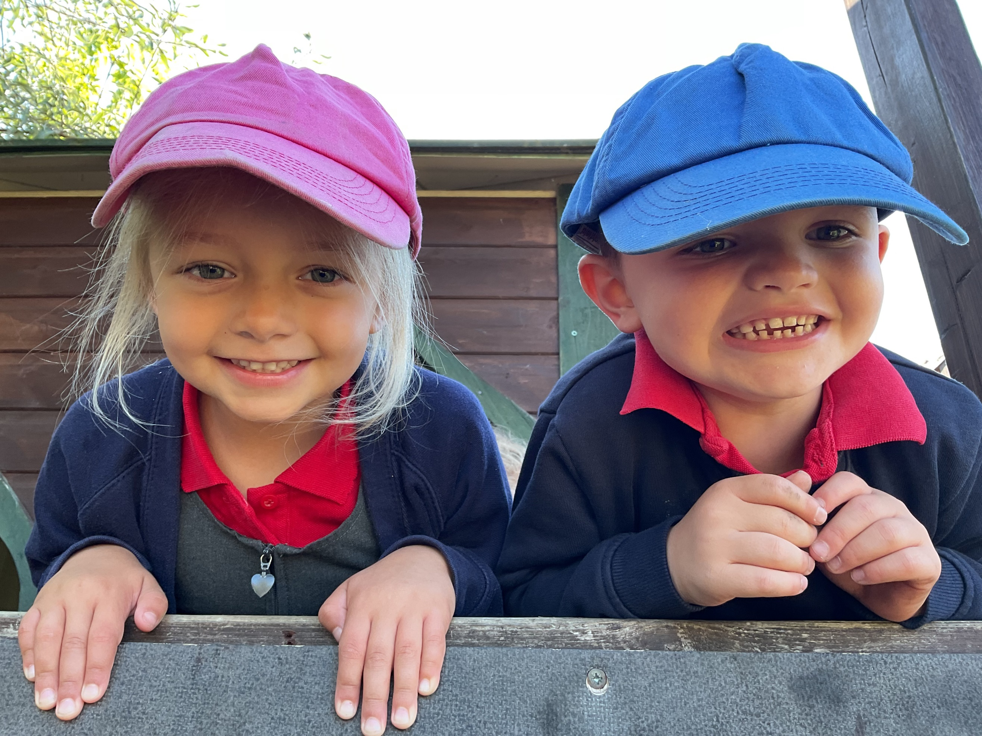
- Personal, Social and Emotional Development
- Physical Development
- Literacy
- Mathematics
- Understanding the World
- Expressive Arts and Design
These goals are achieved through a play-based learning approach which are embodied within ‘Development Matters’, which is a non-compulsory document providing the scaffolding for supporting this Early Years Foundation Stage curriculum in achieving the 17 ELG’s. It is used by staff to support them to understand child development in the different Areas of Learning but not as a checklist.
Children learn through their play in both the indoor and outdoor environment led and facilitated in their learning by adults and their peers. Developing good oracy and communication skills whilst improving social interactions lies at the heart of what we do.
The Early years foundation stage statutory framework and Development matters are 2 key documents which outline why and how we do things in detail.
Impact
How do we measure the impact:
Upon entry to Nursery and Reception children are baselined to assess their starting points and at 3 further points throughout the year to assess their progress and areas for future learning. There is also an additional government digital baseline which we complete with F2 |(Reception) in September which looks at basic skills in English and Maths.
Practitioners build up a picture of each child across the areas through observations, interactions and careful questioning.
Children are not assessed against an age band. It’s now accepted each child develops in different ways, so the previous use of the age bands did not fit everyone fairly. Staff now use their own knowledge of child development to decide each child’s next steps and support needs and allows adults to plan to the learning and interests of the particular children in their class. At the end of the Reception year, children are then assessed against the 17 Early Learning Goals. The ELGs are not used as a test and staff use what they already know about a child to make their decisions. The ELG’s have been adapted to better match up with the National Curriculum in Year 1. This helps children to be better prepared for their move to the next Key Stage. There are no ‘Exceeding’ judgements as children are now encouraged and challenged to have a greater depth and understanding of things before moving onto new learning.

